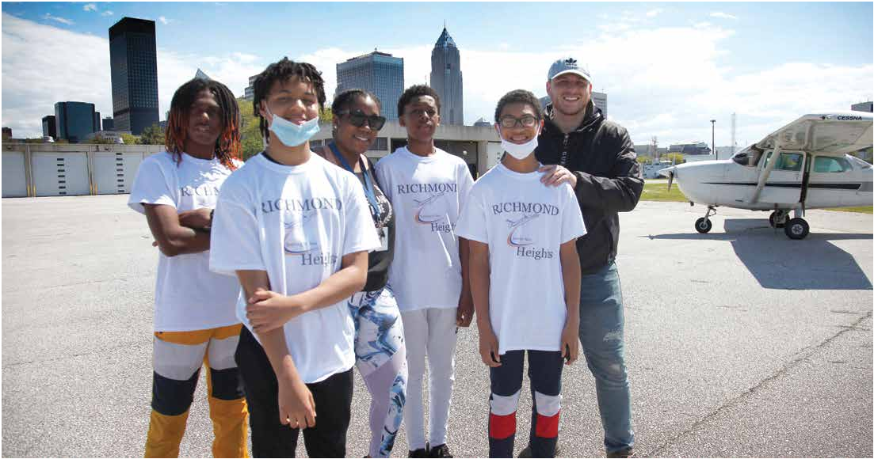
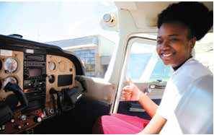
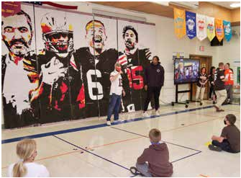
Non Profit Org. U.S. Postage Paid
ESC
Comm
unity
Students and Administrators AT Richmond Heights Local Schools Take Discovery Flights OVER CLEVELAND SKIES
In partnership with T&G Flying Club, Northeast Ohio’s longest-running and largest can earn their FAA Part 107 flying club, a group of six Richmond Heights students, ranging from seventh to Small Unmanned Aircraft twelfth grade, the superintendent and high school principal took Discovery Flights Certificate.
on May 13-14. Superintendent Renée Willis and Principal Marnisha Brown took
the lead on Thursday by being the first ones to fly, as they hoped to allay any fears “The program also includes and anxieties that their students may have. The flights took off from Cuyahoga instruction dealing with County Airport and each student and administrator flew for 30 minutes. Students aircraft mechanics,
had the opportunity to log the flight time toward a private pilot license, and T&G manufacturing, operations, provided students with an introductory flight recording book. marketing, IT, drones, and
Grade’s Cleveland Browns Mural
A moment of a lifetime happened on Thursday, April 29 as Cleveland Browns mural of larger-than-life defensive end Myles Garrett surprised the students and staff at Independence Browns players Nick Primary School. He was so impressed with the fourth-graders’ mural they recently Chubb, Baker Mayfield created for their upcoming art show, that he wanted to see it first-hand and and Myles Garrett, congratulate the young artists. as well as Coach
Stefanski. Adobe With the help of News 5 Cleveland, Garrett’s visit included time for some inquisitive Photoshop helped questions from the fourth graders. Garrett wrapped up his time at the school create the photo by with a walk around the building with all students having an opportunity to say breaking it down into
Cleveland, Ohio Permit No 1312
SUMMER 2021

6393 Oak Tree Blvd., Suite 300 Independence, Ohio 44131
(216) 524-3000 Fax (216) 524-3683
www.escneo.org

Robert A. Mengerink Superintendent

Steve Rogaski Director of Pupil Services

Bruce G. Basalla Treasurer

Governing Board

Christine Krol President

Anthony Miceli Vice President

Carol Fortlage
SUMMER 2021
Frank Mahnic, Jr. @ESCNortheastOH
Tony Hocevar

Independence Primary School Has Surprise Guest to View Fourth

Connection

hello (with lots of barking sounds and chants of “Here We Go Brownies” in the hallways). It was a Cleveland Browns Spirit Day at the school so students and staff just so happened to be wearing their favorite orange and brown spirit gear with many “95” jerseys lining the halls. Garrett also signed his name above his picture on the mural. An autographed helmet was raffled off at the Art Show on May 13 with proceeds going to the school’s art program.

The show, which took place on the baseball fields at Elmwood Park, featured more than 300 pieces of artwork that have been created by the primary school students throughout this school year. Taking part in a three-week art class project,
fourth graders showed off their Cleveland Browns spirit by creating an 18x10 ft.
three colors of red,
yellow and black and created a grid system just like the technique used by the famous artist Chuck Close. Each student figured out which of the three colors to paint on the rectangle to coincide with the larger image of the players.

“This year has been so challenging for our students and staff due to COVID-19,” said Principal TJ Ebert. “We have been in school for most of the year, but we have had to change the way we instruct because of COVID-19 protocols. Now, this won’t be a year remembered as a ‘COVID’ year but the year that Cleveland Browns player Myles Garrett came to meet them. For him to take time to provide
this memory for our students is something they will never forget!”

“This is one of many exciting new opportunities for students who are part of our aviation program. I’m thankful for T&G Flight Club and other community partners who are helping us expand our students’ knowledge of careers in aviation,” said Superintendent Dr. Renée Willis, Richmond Heights. The flights are being offered as part of the school’s aviation programming. Aviation exploration begins in seventh grade and the aviation curriculum begins in ninth grade. Thanks to the Expanding Opportunities for Each Child grant, the district was recently able to expand its resources in its aviation-designated classroom. They purchased 10 flight simulators, which allow students to get hands-on experience while learning
flight navigation from a virtual private pilot. They also have drones so students
much more,” said Willis. “The students are just blown away by the fact that there are just so many careers around aviation they hadn’t thought about because they don’t see those careers.” Students also enjoyed learning about the field with a district-planned speaker
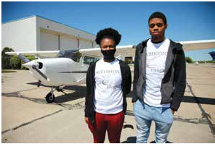
series.

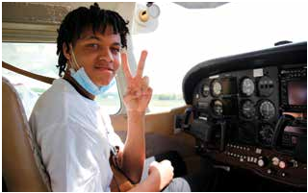
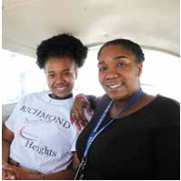
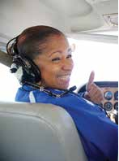
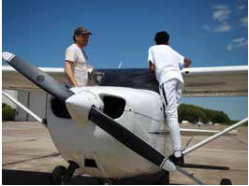
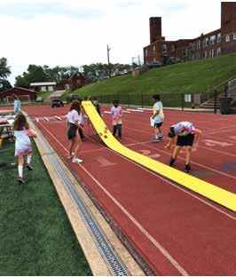
Cuyahoga Heights Elementary School Connects Science and Engineering to Real-World Experiences

What a year for science at Cuyahoga Heights Elementary School! Our students, led by science teacher Barb Currey, took an amazing journey this year by authentically connecting science and engineering to real-world experiences. Students began the year with a virtual experience hosted by physicians and students from Johns Hopkins University who presented interactive information lessons on COVID-19. This provided students the opportunity to ask questions and learn from experts
in the field. In addition, science students performed in
The school year culminated with STEM Day activities, a day in which students applied science concepts to intellectual competition, teamwork, and engineering.
Students cycled through a series of nine different events: Rain Gutter Regatta, Rocket Launch, 3-D Printed Car Race, Catapult Launch, Marble Roller Coaster Building, 3-D Printed Glider Competition, Save Barbie, Electric Circuit Building, and an Egg Drop Competition. Overall, students this year were inspired by the love of learning
and a passion for scientific curiosity.

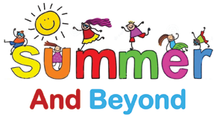
NEW ONLINE VERSION OF 2021 Summer and Beyond DIRECTORY IS NOW AVAILABLE! State Support Team Region 3 (SST3) offers the 2021 Summer and Beyond Directory as a resource to parents,
family members, and school district/community school personnel about extended opportunities around the

three different virtual musicals late-winter and early-spring Cuyahoga County area. Each school year SST3 collaborates with local agencies, camps, and community

related to biology and ecology for families to enjoy.

We Build bridges for . . .

partners around summer activities for students with disabilities. Many of those agencies and organizations offer continued academic skill-building, therapeutic and social-emotional supports throughout the year to assist students with disabilities to become independent and self-sufficient.

To view the 2021 directory, go to http://bit.ly/2021SummerAndBeyond.

Educators | Districts | Agencies | Organizations | Universities & Colleges | Students | Adult Learners | Families & Communities | Businesses
EXCELLENCE IN EDUCATION Recognizing students, peers & educators HUMANITARIAN AWARD RECIPIENTS RECOGNIZED

The ESC of Northeast Ohio and State Support Team–Region 3 recognize students with disabilities, peers, and educators with the annual Excellence in Education Awards. A video was created to celebrate these incredible individuals, along with the great things happening in special education in Northeast Ohio. The Outstanding Student Achievement Award acknowledges achievements of school-age children and youth with disabilities. The Outstanding Peer Achievement Award recognizes students without disabilities who serve as exemplary role models by assisting students with disabilities and establishing positive relationships with them. The
Outstanding Educator Achievement Award honors educators who are the exemplars in designing instructional strategies and programs.
The ESC of Northeast Ohio named several students as recipients of their annual Humanitarian Awards. Recipients were nominated by administrators in their schools for showing leadership and community service as well as possessing great character during the 2020-21 school year. One student from each middle and high school in the communities of Cuyahoga Heights, Independence, and Richmond Heights Local Schools received scholarships and awards. In addition to a cash award,
students receive a personalized plaque, starfish pin, and starfish bookmark. The starfish is the symbol of a story of the impact one person can make in a community.

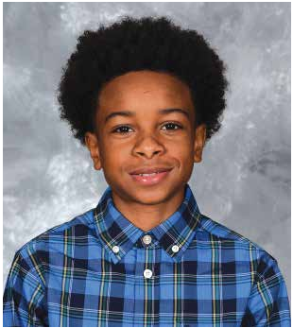
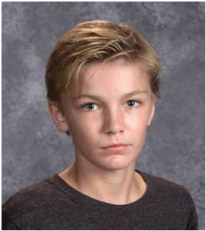
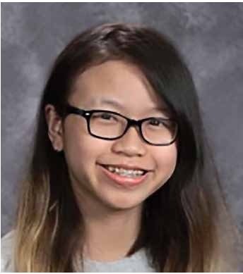
“This event gives us a chance to pause amidst all of the hecticness of a school year and truly just be thankful for special people in this world,” said ESC Superintendent Bob Mengerink. “In my 50 years as an educator, it is students and staff, such as those recognized here, that have made me not only a better educator or administrator, but also a better person. They have forced me to reflect on how I might lead or inspire, but also how I treat others. How I can show compassion. How I should never give up on myself or others, even when it’s hard.” Congratulations to these individuals...

Independence Local Schools

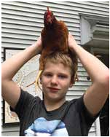
Kevin Patterson and Grace Malvic, Outstanding Student Achievement Award

Kevin consistently shows up to school with a positive attitude. He is always willing to help out other peers when they are struggling. He is polite to teachers and goes
out of his way to thank them for their help or tell them to have a great day. Kevin is well liked by his peers. He is a nice, kind kid that always seems to be doing the right thing even when no one is watching. He is willing
to help out his peers and will go out of his way to talk with someone if he knows they are having a bad day. Kevin works extremely hard. Even when tasks seem
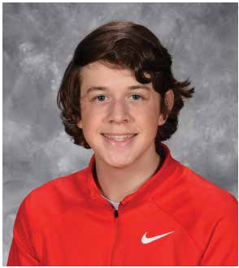
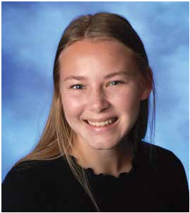
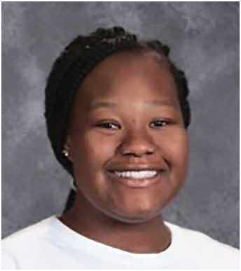
tough or challenging, he is willing to persevere and try his best. He is an independent worker and utilizes the strategies and tools that his teachers have taught him to be successful, even when his disability may directly impact this. He is a role model for other students, he proves time and again that hard work pays off.

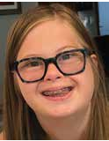
Grace is a genuine, kind-hearted young lady who is always aware of others’ emotions even when she doesn’t feel the best herself. She will often seek out a peer or an adult, in the hallway, in her classroom, or in her community, whether she knows them or not, to say “hello” or to ask if they are okay. Grace participated in several plays at Independence High School, is an active member with her group of friends at the “Upside of Downs,” and takes music classes. She
participated in American Sign Language Class (ASL) and uses it throughout the school day to communicate and teach her peers and her teachers. Grace does not let her disability define her, and it is evident when she works with her peers in her self-contained classroom and when working with her typical peers in the general education classroom.

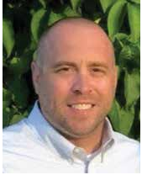
Jamie Vanek,
Outstanding Educator Achievement Award

A genuine student advocate and as the instructional leader of the building, Mr. Vanek’s concern for students transcends ability, and rather encompasses the strengths of ALL students - those with and without disabilities. His focus
is on what students can do as opposed to what they are unable to accomplish. His frequent presence in and around
the building cements his relationship with kids in general. Whether a fist bump, pleasant greeting, or an acknowledgement of sorts, students are happy to interact with him. Mr. Vanek joins IEP/504/behavioral meetings, offering informed insight, suggestions and solutions to individual student needs. His focus consistently is how to make education a positive experience for all students. When possible, and when best for students, Mr. Vanek sees to it that students with disabilities are included
in the regular class environment. However, he also provides our special needs population with services geared toward their individual needs. His gentle reminders to the staff that the middle school focus is to support and recognize the qualities of ALL
students resonates well within the building.
Cuyahoga Heights Local Schools

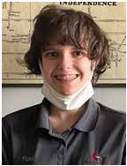
Fiona Navarra,
Outstanding Student Achievement Award

Fiona is a graduating senior at Cuyahoga Heights High School. As a senior, she is taking a challenging course load, including AP Literature at her home school and Digital Design at the Cuyahoga Valley Career Center. Fiona is an engaged and curious student who brings something amazing to all her classes
through her unique insight and dedication to critical thinking. Fiona is in the process of creating a social story about the importance of exercise and how to make exercise more inclusive for people with disabilities. Fiona is an active member of many clubs at Cuyahoga Heights, including the Literary
Society, Gay/Straight Alliance, and Art Club. Fiona demonstrates leadership by setting an example as an engaged and involved student. Fiona is an exceptionally talented artist and is working at both Cuyahoga Heights and the Cuyahoga Valley Career Center to hone that skill as she prepares for post-secondary life. Fiona has grown significantly over her high school career and is graduating as a skilled and confident person. Fiona is a powerful self-advocate, again providing a role model for her peers as a person who can confidently define what she needs to be most successful.

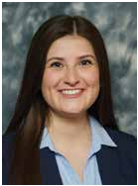
Elena Paparizos,
Outstanding Educator Achievement Award

Elena Paparizos is only in her second year of teaching, but her passion and drive to support the needs of students with disabilities is her calling. Elena started working with students with disabilities when she was only a student herself at Independence High School. She volunteered to work with students in their I-Values program. In
addition, she has worked with students during the summer through various camps and is a member of a number of professional organizations that support the education and development of special needs populations.

Elena’s sensitivity and understanding has been further highlighted throughout the extended school closure, remote learning, hybrid learning and return
to in-person instruction. Her teaching assignment requires her to work with both middle school and high school students who are educated using the extended learning standards. Elena has forged strong relationships with parents to determine how to best support the needs of the family
through multiple learning modalities. She has created professional learning opportunities for her two student attendants. It is very insightful for an intervention specialist to understand that when you develop capacity within those that you work with you are also enhancing the capacity of the students that they interact with on a daily basis. This is the type of educator that we
need more of!

Cuyahoga Heights Middle School Tamir Julious, 8th grade
Tamir has always displayed an intrinsic motivation
to achieve. He has consistently stayed organized, self-motivated and engaged in daily lessons. He is a positive role model for his peers on a daily basis. Tamir shows determination on the court, perseverance in his school and athletic activities, and loyalty toward his friends and our school community. He is someone his friends can count on for encouragement, a funny comment, or an easy hello. Having a conversation with Tamir always brings a smile to our days. Tamir is a leader at school through his daily actions and the kindness he displays toward all students.

Cuyahoga Heights High School Jonathon Nejman, Senior
Jonathon is a man of few words, but many positive
actions. In school, he is honest, respectful, and strives to be his best. He is a quiet leader, who does things the right way. In the time of COVID-19, Jonathon joined forces to help create a podcast with Mr. Kovitch in order to have students connect with the school. This podcast inspired everyone to
get out and be active in a time when everyone was

Independence Middle School Samuel Crooks, 8th grade Sam consistently works above his potential
in all academic classes. He is involved in numerous activities including WEB, basketball, track, and cross country. He is kind, compassionate, friendly, caring, and always has a smile on his face. His
conscientious and empathetic nature makes him wise beyond his years. He shows tremendous strength and courage in and out of the classroom.

Independence High School Makenna McGhee, Senior Makenna is someone that models kindness
and courtesy as a rule. She actively avoids recognition. Her positive spirit is a product of an altruistic attitude. The positive impact she has made on Independence High School will be here long after her graduation. The faculty are appreciative and thankful for
the legacy of kindness and respect that she

Richmond Heights Secondary School Angel Dinh, 8th grade
Angel is on student council and always willing
to serve her community. She is kind, helpful, a stellar scholar and exceptional human being. She never hesitates to put others’ feelings before her own. Her empathy is beyond compare. She’s
a leader but never one to seek the spotlight; instead, she prefers to stand back and help others excel. Angel is a member of the Rise Up after school program and participates in academic and culinary activities, as well as Art Club through our partnership with Arts Inspired Learning. She is a member of the Diversity Club and always seeks out a way to make the best out of any situation.

Richmond Heights Secondary School Rayna Williamson, Senior
Rayna is studious, hard-working and punctual.
She is a College Credit Plus and Excel TECC student. Rayna is a member of the National Honor Society and Excel TECC National Technical Honors Society. She was granted the Northwood University Junior Business Student of the Year Award. She has been a part of DECA, Diversity
Club and Richmond Heights Volleyball Team

Richmond Heights Local Schools Timothy King, Outstanding Educator Achievement Award
staying inside. Teachers, coaches and classmates has left in our school.
have shared countless times when he has gone out
(serving as a starter and co-captain). Rayna has
always managed her time well and often used her

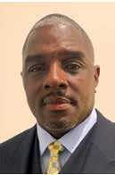
During remote learning, Mr. King was so invested in his students’ emotional well-being that he personally visited students. Mr. King is a friend, mentor, confidante and father figure to his students. His passion for impacting students’ lives is evident from the first moment you meet him. He is a servant leader and is always ready to do whatever it takes for the greater good. This demeanor, coupled with his passion for educating students, makes him one of the teachers that all students want to have and not just our students with disabilities. Mr. King has taught students with multiple handicaps, being sensitive to their challenges. He allowed students the freedom to navigate independently throughout the
school but always close enough in case the student experienced distress or encountered struggles. He knew that students took pride in their independence, yet he was readily available to assist. Mr. King also sensed when students were experiencing trauma and had such a positive rapport with them, that students freely shared with him what things they were dealing with even outside of school. There was never any
differentiation in expectation because of a student’s disability, yet the differentiation came in knowing the various goals and abilities of each of his students.
of his way to do something, without recognition. Often, being soft-spoken creates the opportunity for many of his good deeds to go unnoticed. Never looking for recognition, Jonathon continues to do
his best and make those around him better.
sense of humor to bring levity to any situation. She never shies away from challenges. She also was the ESC Starfish recipient her eighth-grade year and fulfilled her potential in receiving the honor yet again her senior year.

Congratulations, Humanitarian Award Recipients

