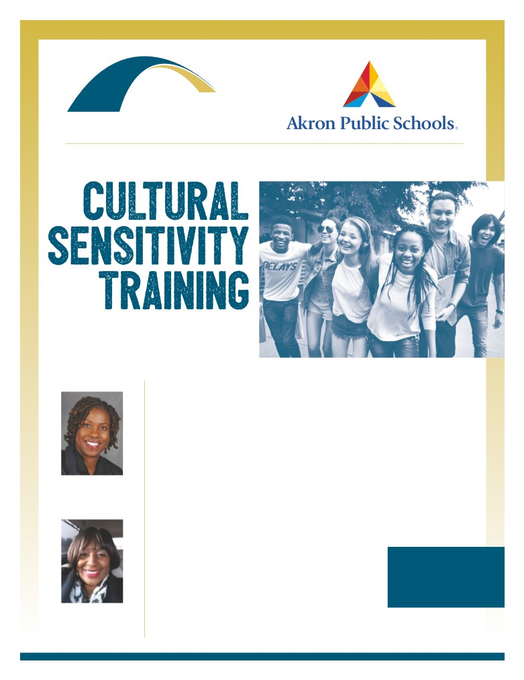

ESC
of Northeast Ohio

ESC of Northeast Ohio and Akron Public Schools present:

Understanding Students
for Improved Academic
Performance and Well-Being

Trainers:

Professional trainers from Akron Public Schools offer unique insight into the lives of

Students and their families at this all-day workshop for administrators, faculty and staff. They will provide a framework for exploring how conditions associated with culture; socio-economic status; trauma; and other factors affect students’ academic performance as well as their emotional well-being.
You will learn how to:
• Create a welcoming school culture and climate
• Understand your students beyond their academic measures

Carla Chapman
Director,
Community,Relations,
Akron Public Schools
• Engage families in learning
• Improve communication between school and home
• Identify resources that strengthen and support students’ well-being
Tuesday, September 10, 2019
Registration 8:30 am
Training 9:00 am - 4:00 pm
Questions? Please contact:

Mae Walker
Administrative Specialist,
Akron Public Schools
Educational Service Center of Northeast Ohio
6393 Oak Tree Boulevard South Independence, Ohio 44131
$50.00 per person (lunch not included)
Registration:
www.escneo.org/protected/MasterCalendar.aspx
Michele Y. Ware
216.524.3000
Michele.Ware@escneo.org

