Northeast Ohio Literacy Network
This network is for dedicated ELA specialists, coaches and teacher leaders who are interested in sharing, discussing, learning and reflecting together to ensure that all students receive the highest quality ELA instruction possible.
Facilitator: Jennifer Miller, K-5 ELA Coach and Specialist

2022-2023 Dates:
October 6, 2022
December 7, 2022
February 9, 2023
May 10, 2023

Time:
8:30- 9:00 AM Sign-in
9:00 AM - 3:30 PM meeting Lunch is on your own Cost: Free!

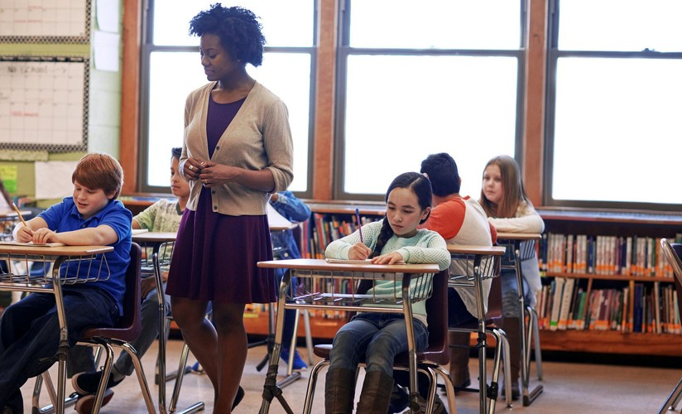
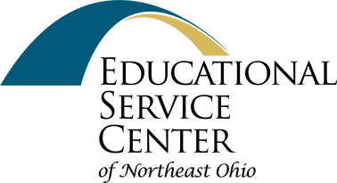
Location:
Educational Service Center of Northeast Ohio, Essex Place, 6393 Oak Tree Boulevard, Independence, Ohio 44131
Registration: www.escneo.org
Professional Development/Calendar of Events
Registration Assistance:
Roni.staimpel@escneo.org

