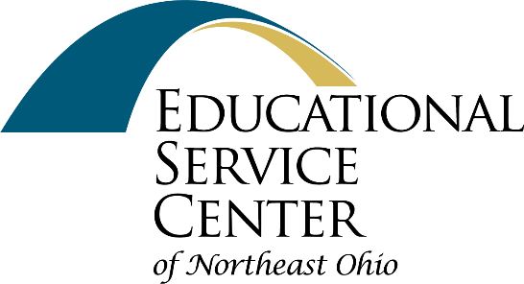
Northeast Ohio School Psychologists Network

Location: Virtual Sessions via Zoom

Description: This network provides school psychologists the opportunity to reflect and collaborate on how to best support the student, family and staff needs within the communities they serve. Each session includes information sharing, targeted discussion, and case/issue collaboration. Topics are planned based on input and feedback from network members.
School psychologists work in a range of educational settings and roles; all are welcome to attend.
Facilitators:
Christy Roshong, ESCNEO Consultant;
Sal Karanouh-Schuler, School Psychologist
Cost: Free
Time: 9:00-10:30 AM; host will open session at 8:45 AM for registration and networking.
Professional Contact Hours: 1.50

Register at:  http://www.escneo.org/  Click on view calendar  under upcoming events  Zoom meeting link will be sent to participants 1-2 days prior to meeting.  For questions contact  Christy Roshong  Christy.roshong@escneo.org  Essex Place  6393 Oak Tree Blvd.  Independence, Ohio 44131 | 2022-2023 Meeting Dates*:  Friday, August 26, 2022  Thursday, October 13, 2022  Friday, December 2, 2022  Thursday, January 12, 2023  Friday March 3, 2023  Thursday, May 04, 2023  *subject to change based on registration.

